College of Engineering, Thiruvananthapuram

Object-Oriented Programming Lab



Anirudh A. V.

S2 CSE R2, Roll No. 11

Department of Computer Science

& Engineering

February 7, 2022

1. **Area of a Rectangle – Question 1**
   1. Aim

To write a Java program to print the area of a rectangle by creating a class named '***Area'*** having two methods. The first method named ***'setDim'*** takes the length and breadth of the rectangle as parameters and the second method named ***'getArea'*** returns the area of the rectangle. The length and breadth of a rectangle are entered through the keyboard.

* 1. Algorithm

1. Start
2. Create a class Area with data members ‘length’ and ‘breadth’.
3. Define a method ‘setDim’ such that it takes the length and breadth of the rectangle given as user input and assigns it to the data members ‘length’ and ‘breadth’.
4. Define a method ‘getArea’ which returns the product of the data members ‘length’ and ‘breadth’.
5. Define a public static void main method that receives the user input as well as calls the above-defined methods.
6. Display the Area of the rectangle as the output.
7. Stop
   1. Code

import java.util.Scanner;

public class Area {

    int length;

    int breadth;

    void setDim(int a, int b){

        this.length = a;

        this.breadth = b;

    }

    int getArea(){

        return length*breadth;

    }

    public static void main(String[] args) {

        Scanner sc = new Scanner(System.in);

        System.out.println("Enter the length of the rectangle : ");

        int a = sc.nextInt();

        System.out.println("Enter the breadth of the rectangle : ");

        int b = sc.nextInt();

        Area ar = new Area();

        ar.setDim(a, b);

        System.out.println("Area is "+ ar.getArea());

        sc.close();

    }

}

* 1. Sample Output

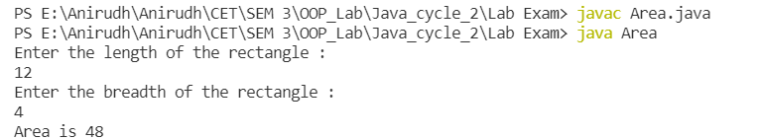

1. **Inheritance– Question 2**
   1. Aim

To create a class named ***'Rectangle'*** with two data members ***'length'*** and ***'breadth'*** and two methods to print the area and perimeter of the rectangle respectively. Its constructor having parameters length and breadth is used to initialize the length and breadth of the rectangle. Let class ***'Square'*** inherit the ***'Rectangle'*** class with its constructor having a parameter for its side(suppose *s*) calling the constructor of its parent class as '***super(s,s)'.*** Print the area and perimeter of a rectangle and a square.

* 1. Algorithm

1. Start
2. Create a class ‘Rectangle’ with data members ‘length’ and ‘breadth’.
3. Define a parameterized constructor for class ‘Rectangle’ which takes the length and breadth of the quadrilateral as the parameter to initialize data members ‘length’ and ‘breadth’.
4. Define method ‘Area’ such that it returns the product of data members ‘length’ and ‘breadth’.
5. Define method ‘Perimeter’ such that it returns twice the sum of the data members ‘length’ and ‘breadth’.
6. Create a class ‘Square’ that inherits class ‘Rectangle’.
7. Create the main class and define a static main method to receive input from the user.
8. Display the Area and Perimeter of both the Rectangle and the Square.
9. Stop
   1. Code

import java.util.Scanner;

class Rectangle {

    int length;

    int breadth;

    public Rectangle(int a, int b) {

        length = a;

        breadth = b;

    }

    void area() {

        System.out.println("Area is " + length * breadth);

    }

    void perimeter() {

        System.out.println("Perimeter is " + 2 * (length + breadth));

    }

}

class Square extends Rectangle{

    public Square(int s){

        super(s, s);

    }

}

public class Shape {

    public static void main(String[] args) {

        Scanner sc = new Scanner(System.in);

        System.out.println("Enter the length of rectangle : ");

        int a = sc.nextInt();

        System.out.println("Enter the breadth of rectangle : ");

        int b = sc.nextInt();

        Rectangle rc = new Rectangle(a, b);

        rc.area();

        rc.perimeter();

        System.out.println("\nEnter the side of square : ");

        int s = sc.nextInt();

        Square sq = new Square(s);

        sq.area();

        sq.perimeter();

        sc.close();

    }

}

* 1. Sample Output

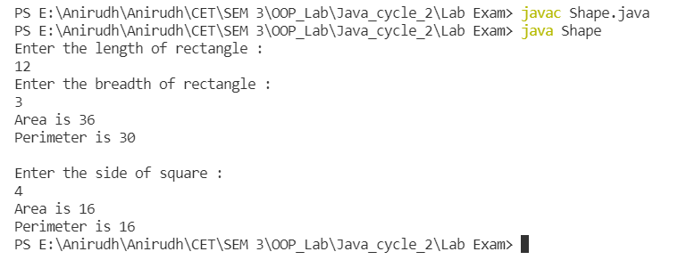

1. **Employee Salary – Question 4**
   1. Aim

To Write a program by creating an '***Employee'*** class having the following methods and printing the final salary.

1 - ***'getInfo()'*** which takes the salary and number of hours of work per day of the employee as a parameter.

2 - ***'AddSal()'*** which adds ***$10*** to the salary of the employee if it is less than ***$500***.

3 - ***'AddWork()'*** which adds ***$5*** to the salary of the employee if the number of hours of work per day is more than ***6*** hours.

* 1. Algorithm

1. Start
2. Create a class ‘Employee’ with data members ‘Salary’ and ‘work_per_day’.
3. Define a method ‘getInfo’ which has ‘Salary’ and ‘work_per_day’ as parameters.
4. Define a method ‘AddSal’ such that if Salary < 500
   1. Increment Salary by 10.
5. Define a method ‘AddWork’ such if work_per_day > 6
   1. Increment Salary by 5.
6. Define a static main method to receive user inputs.
7. Create a menu-driven functionality such that the above define methods can be called.
8. Display the final Salary of the Employee.
9. Stop
   1. Code

import java.util.Scanner;

public class Employee {

    int Salary;

    int work_per_day;

    void getInfo(int sal, int work) {

        this.Salary = sal;

        this.work_per_day = work;

    }

    void AddSal() {

        if (Salary < 500) {

            System.out.println("Since the Salary is less than $500, $10 is added!");

            Salary = Salary + 10;

        }

    }

    void AddWork() {

        if (work_per_day > 6) {

            System.out.println("Since the no. of working hours is more than 6, $5 is added!");

            Salary = Salary + 5;

        }

    }

    public static void main(String[] args) {

        Scanner sc = new Scanner(System.in);

        System.out.println("Enter the Salary of the Employee");

        int sal = sc.nextInt();

        System.out.println("Enter the number of work hours per day of the Employee");

        int work = sc.nextInt();

        Employee em = new Employee();

        em.getInfo(sal, work);

        int response = 1, choice;

        do {

            System.out.println("\t\nM E N U");

            System.out.println("1. Low Salary\n2. More Work\n3. Print final Salary\n4. Exit");

            System.out.printf("\n\t->");

            choice = sc.nextInt();

            switch (choice) {

                case 1:

                    em.AddSal();

                    break;

                case 2:

                    em.AddWork();

                    break;

                case 3:

                    System.out.println("The final Salary is " + em.Salary);

                    break;

                case 4:

                    System.out.println("\n\tTerminating Program....\n");

                    System.exit(0);

                    break;

                default:

                    break;

            }

        } while (response == 1);

        sc.close();

    }

}

* 1. Sample Output

